PASCHAL IFEWULU PROJECT CHAPTER 4 AND 5
CHAPTER 4

Query 1:
Question: Retrieve the names of all football leagues whose revenue is greater than 50,000.
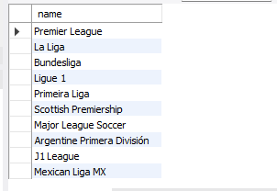
SELECT name
FROM footballLeague
WHERE revenue > 50000;

Query 2:
Question: List all the staff members whose first name starts with the letter 'A'
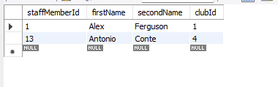
SELECT staffMemberId, firstName, secondName, clubId
FROM StaffMember
WHERE firstName LIKE 'A%'

Query 3:
Question: Find the names and addresses of players born after 1990, ordered by their date of birth.
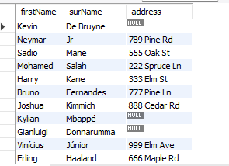
SELECT firstName, surName, address
FROM Player
WHERE dateOfBirth > '1990-01-01'
ORDER BY dateOfBirth;

Query 4:
Question: Retrieve the names of countries of origin with at least two words in their name.
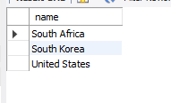
SELECT name
FROM CountryOfOrigin
WHERE CHAR_LENGTH(name) - CHAR_LENGTH(REPLACE(name, ' ', '')) >= 1;

Query 5:
Question: Find the names and start dates of cup competitions that have already started.
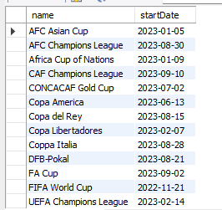
SELECT name, startDate
FROM CupCompetition
WHERE startDate <= CURDATE();
CHAPTER 5

Query 1:
Question: Retrieve the names of all staff members along with their roles in the club named 'Real Madrid'.
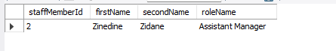
SELECT SM.staffMemberId, SM.firstName, SM.secondName, (R.name) AS roleName
FROM StaffMember SM
JOIN StaffMemberRole SMR ON SM.staffMemberId = SMR.staffMemberId
JOIN Role R ON SMR.roleId = R.roleId
WHERE SM.clubId = (SELECT clubId FROM Club WHERE name = 'Real Madrid');

Query 2:
Question: List the names of all clubs along with the names of the football leagues they are associated with.
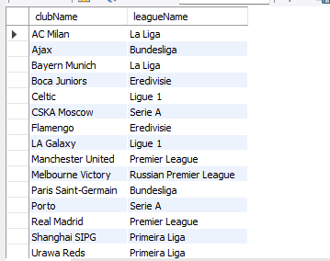
SELECT C.name AS clubName, F.name AS leagueName
FROM Club C
LEFT JOIN FootballLeagueClub FLC ON C.clubId = FLC.clubId
LEFT JOIN FootballLeague F ON FLC.footballLeagueId = F.footballLeagueId;

Query 3:
Question: Retrieve the names of players, their clubs, and the countries of origin for players born after 1995.
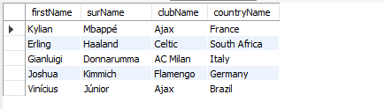
SELECT P.firstName, P.surName, C.name AS clubName, COO.name AS countryName
FROM Player P
JOIN Club C ON P.clubId = C.clubId
JOIN CountryOfOrigin COO ON P.countryOfOriginId = COO.countryOfOriginId
WHERE P.dateOfBirth > '1995-01-01';

Query 4:
Question: Find the names of cup competitions along with the names of the clubs participating in them.
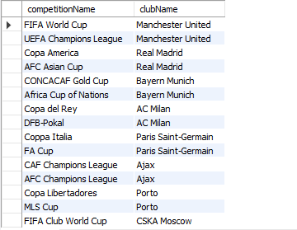
SELECT CC.name AS competitionName, C.name AS clubName
FROM CupCompetitionClub CCC
JOIN CupCompetition CC ON CCC.cupCompetitionId = CC.cupCompetitionId
JOIN Club C ON CCC.clubId = C.clubId;

Query 5:
Question: Retrieve the names of football leagues and the names of clubs that belong to them. Include football leagues even if they don't have associated clubs.
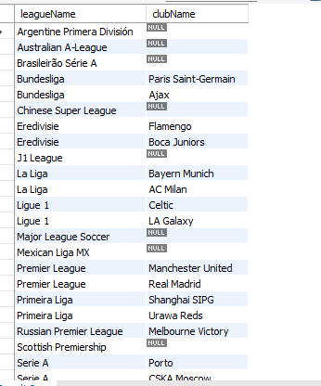
SELECT FL.name AS leagueName, C.name AS clubName
FROM FootballLeague FL
LEFT JOIN FootballLeagueClub FLC ON FL.footballLeagueId = FLC.footballLeagueId
LEFT JOIN Club C ON FLC.clubId = C.clubId;

